**NEDB2101 – Database Administration**

**Semester 1, 2024-2025**

**Course Coordinator: Dr. Murtaza Ali Khan**

**Lab 7 - Create Database using SQLite, Python and Google Colab**

**Objectives**

* Understand Google Colab
* Understand SQLite
* Create a database and table using SQLite and Python in Google Colab
* Read and display records from the table

**Learning Outcomes:**

* Students can create a database and table using SQLite and Python in Google Colab and read and display records from the table

**Google Colab (Colaboratory)**

* Colab is a hosted Jupyter Notebook service that requires no setup to use and provides free access to computing resources, including GPUs and TPUs.
* Colab notebooks are stored in Google Drive, or can be loaded from GitHub. Colab notebooks can be shared just as you would with Google Docs or Sheets.
* Code is executed in a virtual machine private to your account. Virtual machines are deleted when idle for a while, and have a maximum lifetime enforced by the Colab service
* You can download any Colab notebook that you’ve created from Google Drive
* You can import an existing Jupyter/IPython notebook into Colab
* Selecting (Runtime > Disconnect and delete runtime) to return all managed virtual machines assigned to you to their original state.
* Colab is especially well suited to machine learning, data science, and education.

**SQLite**

* SQLite is a C-language library that implements a small, fast, self-contained, high-reliability, full-featured, SQL database engine. SQLite is the most used database engine in the world. SQLite is built into all mobile phones and most computers and comes bundled inside countless other applications that people use every day.
* SQLite3 can be integrated with Python using sqlite3 module. It provides an SQL interface.

**Open notebook**

1. Go to <https://colab.research.google.com/>

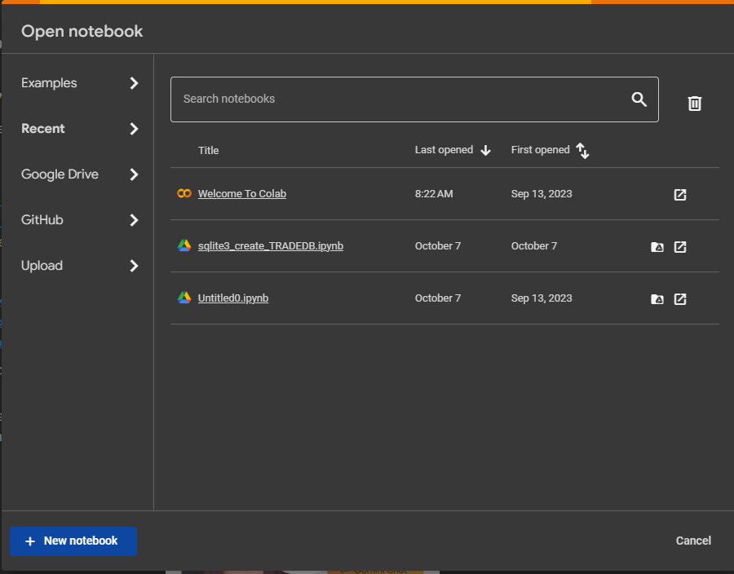

1. Click on **+New notebook**. A new notebook will open

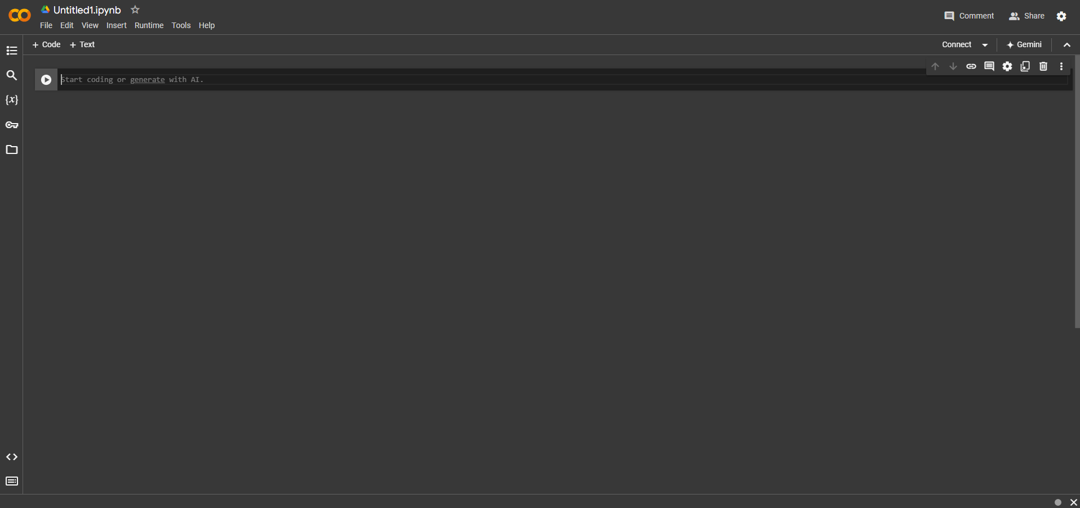

1. Write the code in a cell and run (ctrl + enter)

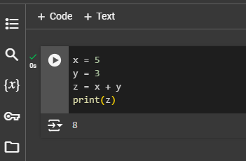

1. Insert text by pressing **+ Text.** Insert new cells by pressing **+Code**

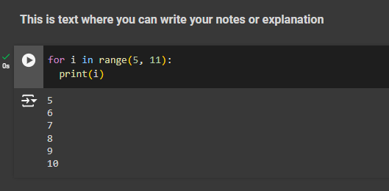

1. Delete cells by pressing 
2. Use File menu for saving and rename you notebook

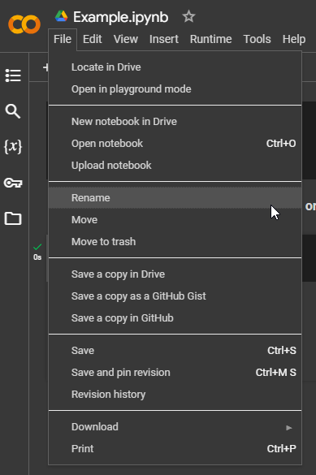

1. Go to your Google drive, you will find a folder **Colab Notebooks**.

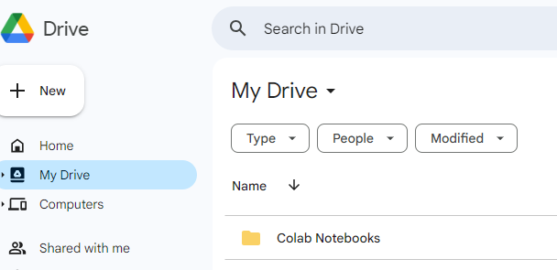

1. Inside this folder your notebooks are saved. You can double click on any notebook, it will be opened in the Colab for editing

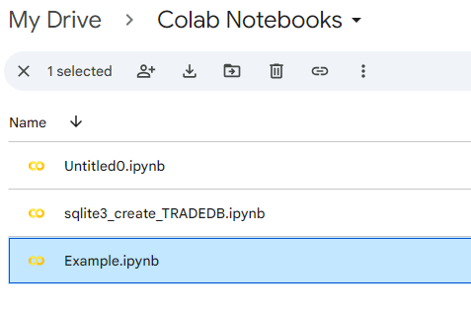

**Create Database Using SQLite and Python in Google Colab**

We will now create a Python script in Colab to implement the database functionality as follows:

1. Import the sqlite3 library to work with SQLite databases
2. Establish a connection to the database named "TRADE_DB", If the database doesn't exist, it will be created
3. Create a cursor object to execute SQL commands
4. Create a table named "ITEM" with columns for ItemCode, PurchaseDate, ItemName, ItemPrice, and Category
5. Insert data into the ITEM table
6. Commit the changes to the database to make them permanent
7. Fetch all rows from the ITEM table and store them in the 'row' variable
8. Iterate through each row in the ITEM table and print it
9. Close the database connection

**Lab Task**

1. Open the new notebook in Colab and write the following code.
2. Save your code with name **sqlite3_Create_TRADE_DB**
3. Run the code

We will discuss this code in the lab

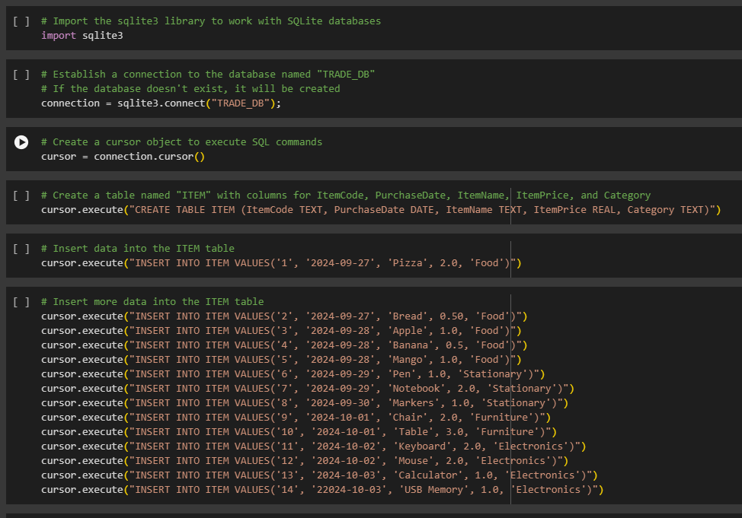

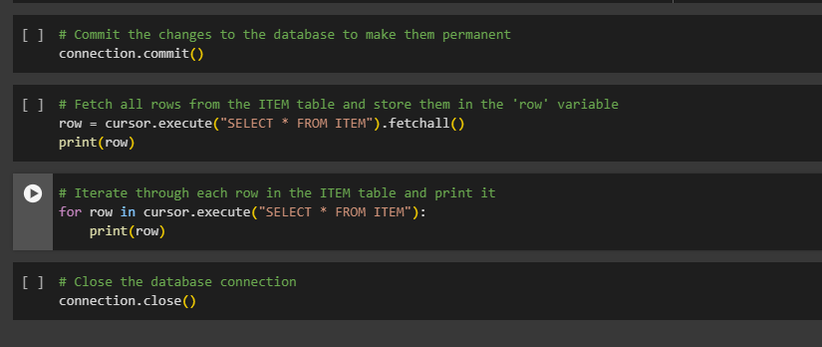

**Code Link on GitHub:**

You can click on the following link to open the GitHub page of the code.

<https://github.com/drmurtazakhan/Python/blob/main/sqlite3_Create_TRADE_DB.ipynb>

Then click on the link .

The code will be open in the Google Colab.

**References:**

* <https://colab.google/>
* <https://www.sqlite.org/>
* <https://www.tutorialspoint.com/sqlite/sqlite_python.htm>